Notes for MLOps project – Visa approval prediction app
Github link: https://github.com/loicFraichlin/MLOps---Visa-Approval-prediction-app.git

- It is important to firstly setup a good project structure, so that the app is maintainable, ready for production and easy to debug. For this mlops project we are going to follow this structure:

We define it within the template.py file, so that folders and files are created automatically when executing the template file

Project_name folder:
f"{project_name}/__init__.py",

Components folder:
f"{project_name}/components/__init__.py",
f"{project_name}/components/data_ingestion.py",
f"{project_name}/components/data_ingestion.py",
f"{project_name}/components/data_transformation.py",
f"{project_name}/components/model_trainer.py",
f"{project_name}/components/model_evaluation.py",
f"{project_name}/components/model_pusher.py",

Configuration folder:
f"{project_name}/configuration/__init__.py",

Constants folder:
f"{project_name}/constants/__init__.py",

Entity folder:
f"{project_name}/entity/__init__.py",
f"{project_name}/entity/config_entity.py",
f"{project_name}/entity/artifact_entity.py",

Logger folder:
f"{project_name}/logger/__init__.py",

Pipeline folder:
f"{project_name}/pipeline/__init__.py",
f"{project_name}/pipeline/training_pipeline.py",
f"{project_name}/pipeline/prediction_pipeline.py",

Utils folder:
f"{project_name}/utils/__init__.py",
f"{project_name}/utils/main_utils.py",

"app.py",
"requirements.txt”: all python packages we need to install
"Dockerfile",
".dockerignore",
"demo.py",
"setup.py": where we define local packages to install

Config folder:
"config/model.yaml",
"config/schema.yaml"

- We set the database on mongodb Atlas:
-creation of an account and cluster on mongodb atlas
-download our dataset named EasyVisa_dataset on Kaggle, and then import it on our cluster as a collection.
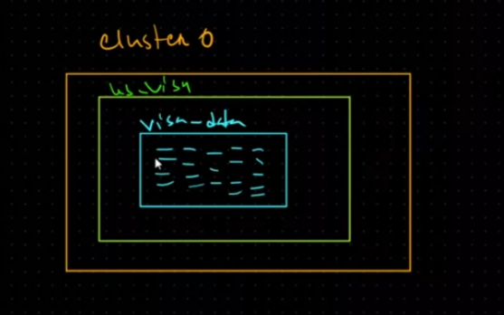

The image above describes how data is structured on mongodb.
Cluster -> database -> collection

- Exploratory data analysis, Feature engineering and model training on jupyter notebook.

  - EDA
-Firstly check: null values, duplicated rows
-check the unique values of each column, also the number of unique values
-Separate numeric from categorical columns, to have a better exploration

-check the proportion of unique value from each categorical column, so that we know the predominant categories and get some insights.

- do univariate analysis to understand the distribution of values for a single variable. (others type of analysis: bivariate = analysis of two variables, multivariate = analysis of two or more variables)

Numerical features
We use kdeplot from seaborn to check density per value.
Interpretations:
*Number of peaks
- 1 peak → Unimodal distribution (one main group)
- 2 peaks → Bimodal distribution (two groups / populations)
- >2 peaks → Multimodal or mixed processes
When we got many small peaks, this could mean the feature is discrete.
*Skewness
When the tail of the skewed part of curve it’s too long, it may be because of outliers/rare values
Categorical features
We use a countplot from seaborn to check dominant categories in each feature.

- Multivariate analysis
We check multicollinearity in both numerical and categorical features because highly correlated or redundant features can inflate variance, make coefficients unstable, reduce interpretability, and harm the performance of models like linear and logistic regression. Even categorical features can create redundancy after encoding, so they must be checked as well.
Numerical features:
We use the corr() function to check that.
Categorical features:
We can use chi-squared test to check dependence and cramer’s V to check how strong the dependence is.
H0: the two features are independent
H1: the two features are dependent.
If p-value <0.05, reject H0 -> features are dependent
If p-value >= 0.05, fail to reject H0 -> features are independent.

When 2 features are highly correlated or dependent, we can drop one of them or combine them.

We also check correlation between features and target, to know which features are highly correlated to the target.
categorical features with categorical target -> Chi-squared and cramer’s V
Numerical features with categorical target -> Anova/F-Test
Numerical features with numerical target -> Pearson/Kendall with df.corr()

Distribution of numerical features by target feature (in case we get a categorical target or a numerical one with few values).
Here we can use boxplots and histograms to show how features are distributed according to the target.

At the end we do some visualizations responding to questions around the problematic.

  - Feature engineering

- Data Cleaning: we handle missing values, duplicates.
We can check the percentage of missing values for each feature in the dataset.
- Feature engineering:

*Feature extraction:
we convert year to age here because it is more meaningful for the model. To get age we subtract the current year by company’s year of establishment. Thus, our model can track the influence of a company’s age on the prediction of visa decision at the time it is made.

*Power transformation:
Some of the numerical values have skewed distribution, to fix that, we can use yeo-jonhson method. As a clarification scaling doesn’t fix skewness, it only adjusts units between values of a feature. But power transformation changes the distribution of a numerical value so that it becomes more Gaussian, more symmetric.

We are going to set a column transformer pipeline that will ensure:
-one hot encoding for columns having lesser unique values and not ordinal
-ordinal encoding for columns having many unique values
-power transformation to fix skewness
-standard scaler to scale features

- Before executing any transformation, we are going to split our data first to avoid data leakage. After that the column transformer to x_train set.
- We notice a class imbalance, so we are going to use resampling on train set to fix this.

  - Model and evaluation
We test several models with their default hyperparameters, find the best ones. And then optimize it through gridsearch.
- We discover that when we got low recall on test set, it’s because of imbalance class in dataset. Using resampling helps to get better recall (but accuracy decreases slightly), so the model predicts also the minority class.

